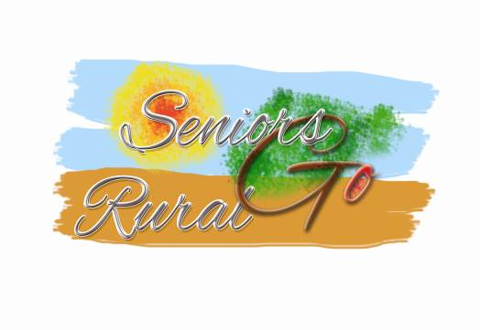

**Opening the countryside for the 55+**

**After almost 18 month of work, the “Seniors Go Rural” project presents the results of its activities. A reduced yet comprehensive list of rules and requirements sets the frame for age-group friendly tourism services. Based on these criteria, new and innovative products were created and tested. The “Silver Suitcase” logo identifies adequate services to the target group, and the associated Guest Card provides special conditions and value-added services to them.**

From the very start of the project, the aim was to focus on senior-friendly services in small rural tourism services, their adaptation along basic rules and criteria, and put them on the market through different innovative models of promotion and sales for individual visitors or small groups.

As main results, we are proud to present at this conference:

**(1) Guidelines for a “Senior-friendly” rural tourism product.** The content of these guidelines is a result of research and testing by the representative transnational organisation EuroGites, provider organistions in Belgium, Latvia, Lithuania, and Norway, and the participating senior organisations from Holland and Norway. They establish specific criteria for rural tourism hospitality services and destinations to receive Seniors. For rural tourism businesses, summarized technical advice is given on the preparation of products that are adequate to senior needs.

**(2) Products along these guidelines** were created and put on the market in four different countries: Belgium, Latvia, Lithuania, and Norway. They include both individual services (accommodation, spas, … ) and complete simple packages for several days. Marketing was initially done by the partner Nationaal Ouderenfonds for testing. By the end of the project, it will be continued and extended to more countries and products through a dedicated website at [**http://sengor.eurogites.org**](http://sengor.eurogites.org)

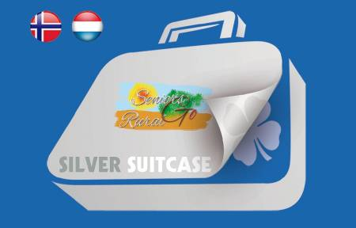**(3) “Silver Suitcase” logo and Guest Card.** The accredited senior-friendly products are made accessible to Seniors under specially favourable conditions during certain times of the year. For a homogeneous promotion, sales, and maybe future payment across Europe, the “Silver Suitcase” logo was proposed to identify adequate tourism services. It is complemented by a Guest ID Card that accredits the cardholder to receive the agreed conditions.

**Summary**

**Main outcomes**

* + “Seniors Go Rural” accreditation criteria
  + Guidelines for rural tourism businesses on products for the senior market
  + 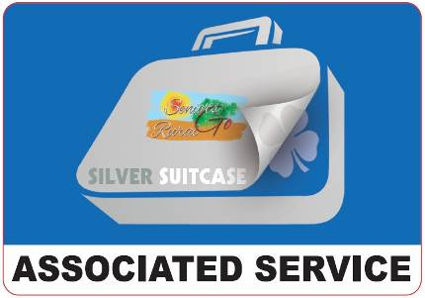Framework agreements between rural tourism provider and senior associations to jointly promote and incentive the transnational travel of individual seniors in off-season.
  + Pilot Rural Tourism products (transnational in the Baltics / regional in NO and BE)
  + Website for information and promotion
  + Promotion tools: product brochure (for clients), information brochure (for providers and destinations)
  + Exploitation plan

**Lead partner/coordinator**

Lauku Celotajs (LV)

**Partners**

EuroGites – European Federation of Rural Tourism (EU / FR)

HANEN (NO)

LKTA – Lithuanian Rural Tourism Association (LT)

NFE – Nationaal Ouderenfond (NL)

Toerisme Vlaams-Brabant (BE)

*ANCESCAO (IT) -- until March 2015*

**Contact persons**

Asnate Ziemele [asnate@celotajs.lv](mailto:asnate@celotajs.lv) [www.celotajs.lv](http://www.celotajs.lv)

Klaus Ehrlich [general.secretary@eurogites.org](mailto:general.secretary@eurogites.org) [www.eurogites.org](http://www.eurogites.org)