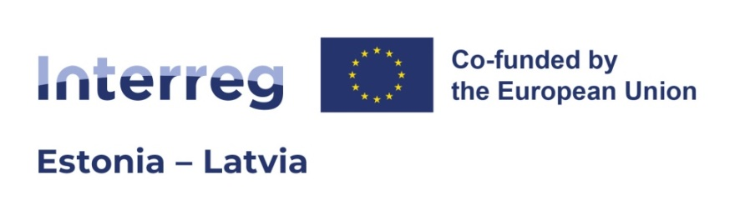

|  |  |
| --- | --- |
| **Project:** | **Forest and Coastal Hiking Trails' accessibility improvement for different social groups** |
| **Project ID and acronym:** | EE-LV00013 – Accessible Hiking Trails |
| **Project Partners:** | Latvian Country Tourism Association "Lauku celotajs" (Lead Partner)  Kurzeme planning region (PP2)  Vidzeme Planning region (PP3)  Movement Spontaneous (PP4)  Riga Planning Region (PP5)  NGO Estonian Rural Tourism (PP6)  Pärnu Bay Rotary Club (PP7)  The Municipality of Häädemeeste (PP8)  Setomaa Municipality Government (PP9)  NGO Peipsimaa Tourism (PP10) |

**4th PROJECT PARTNER MEETING**

25-26th September, 2024, Cēsis, Vidzeme

Vanadziņa Restaurant, <https://vanadzinarestorans.lv/en/>

**AGENDA**

|  |  |
| --- | --- |
| **25.09.2024.** | |
| 11:00 - 12:30 | 4th PROJECT PARTNER MEETING  Project info  3rd project report, 3rd partner reports, 4th reporting period 01.07.2024.-31.10.2024.)  **WP1 Joint development of accessibility solutions**  Activity 1.1, Involvement of the targeted social groups  Activity 1.2, Involvement of local communities  Activity 1.3, Development of the accessibility solutions – information by partners/groups <https://docs.google.com/spreadsheets/d/1xpiLt2JBmPtq3xyS6yrBtJ98JXFCL1h2CqfpzGaRYQA/edit#gid=1435449887> |
|  | pusdienas Vanadziņa Restaurant  <https://vanadzinarestorans.lv/en/> |
| 13:30 - 17:00  Coffee-break in between | Activity 1.4, Training materials and training: videos from piloting, guidelines (school children – MS, guides – ERTO, guidelines HF – LC+VPR)  **WP3 Pilot actions of the accessibility solutions in the improved sites**  Partner presentations/info on planned investments and piloting, cooperation between the partners for the 7 accessibility solutions next steps.  **WP2 Marketing and promotion**  Activity 2.1, Special interest hikes for social inclusion of the targeted social groups. LC  Activity 2.2, Hikers friendly sign for accessibility. LC  Activity 2.4, Printed map – LC+MS  Activity 2.7, Cooperation with international hiking community – ERA meeting + International event in May, Latvia-Kurzeme  Next steps and next meeting |
| 18:00 | Dinner ?? |
| **26.09.2024.** | |
| 8:30 – 10:00 | Project meeting. **Marketing continues**:  Activity 2.5, Video reels. MS + LC  Activity 2.3, Web site and digital improvements. LC  Activity 2.8, Promotion items  Activity 2.6, Communication – all responsible to report  Info from VPR on Changes of plans Children-friendly hikes |
| 10:00 - 12:00 | A hike on the improved site by VPR - the Forest Trail section. |

We have reserved the available rooms in Hotel CĒSIS. We managed to agree that the **reservation is valid until August 15**, so please make reservations using the **code "Accessible Hiking Trails"** by sending a request to the e-mail: [reservation@hotelcesis.lv](mailto:reservation@hotelcesis.lv)

Currently, 7 double rooms (for 14 persons) and 6 single rooms (for 6 persons) are available, the double rooms, of course, can also be used for one person.

Room prices:

1 single room - 64 EUR

1 double room for single use - 60 EUR

1 double room (2 guests) - 64 EUR

Breakfast is included in the price.

Other options are:

Hotel "KATRINA" (simple economy class hotel), unfortunately they do not offer breakfast;

Hotel "Villa Santa" <https://www.villasanta.lv/en> (luxury class hotel, slightly outside the city center);

Of course, you can also find other options using [www.booking.com](http://www.booking.com).

Please make reservations for the hotel by August 15, if you decide to stay in Hotel CĒSIS, and feel free to contact us if you have any questions!

More info about the meeting –

Eva Meijere, +371 25665567, [eva.meijere@vidzeme.lv](mailto:eva.meijere@vidzeme.lv)

Toms Ziemelis, +371 28651372, [toms@celotajs.lv](mailto:toms@celotajs.lv)