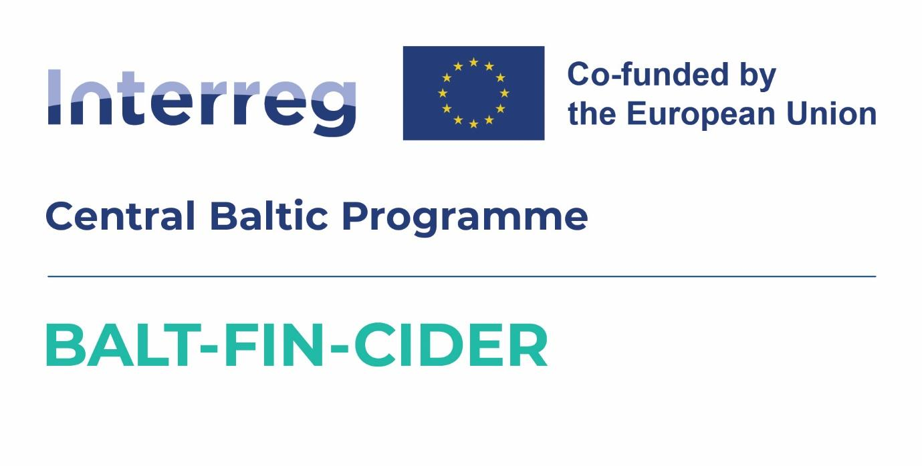

Project: | Exports of the Baltic and Finnish Craft Ciders to Australia
Project ID and  acronym: | CB0700297– BALT-FIN-CIDER
Project Partners: | Latvian Country Tourism Association "Lauku celotajs" (Lead Partner)  NGO Estonian Rural Tourism

2nd PROJECT PARTNER MEETING AGENDA

8th of September 2025,
Hestia Hotel Strand,
Pärnu, Estonia

Monday, September 8, 2025

9:40 - 10:00 | Registration and welcome coffee
10:00-11:00 | FACE-TO-FACE MEETING (WITH PROJECT PARTNERS AND SMEs PARTICIPATING)  - Opening, updates and news from Project Partners  - Representing Baltic cider at sales and marketing events, such as ProWine in Singapore and Düsseldorf, CiderCon, The 60th Australian Latvian Arts Festival (in Adelaide, 26th - 31st December, 2025) etc.
11:00-12:30 | Gabe Cook technical webinar together with Sigrid Gertsen Schibbye (Lallemand)  Cider Making Run through (presented by Gabe Cook)  - Apple selection  - Milling/pressing  Yeast & Nutrition (presented by Sigrid Gertsen Schibbye)  - Critical role in cider making process  - Selection of different yeasts for different needs and purposes  - Importance of inoculation  - The role of balanced nutrition  - Controlling microbiology - pH, So2 and associated products
12:30-13:30 | Lunch
13:30-14:00 | Project partner meeting, discussions
14.00-15.30 | Gabe Cook Commercial Webinar together with Tom Oliver (Oliver's Cider & Perry)  All the considerations that need to be made in order to establish a viable enterprise  - Know your drinker  - Sensory profile  - Pack type  - Brand identity  - Route to market
15:30-16:00 | Coffee break
16:00-18:00 | Steering group meeting. Providing information about State support for export activities.  Discussions on Baltic cider participation in international fairs/events. Rules and possibilities;  Developing first BalticCider Newsletter, content, distribution.
19:00 | Dinner

